CS 1632 – DELIVERABLE 4: Performance Testing Using VisualVM

GitHub: https://github.com/jkellyjr/CS1632_Deliverable4

By: John Kelly Jr

Summary

Luckily, I did not face too many issues during the completion of this project. I have never done extensive performance testing prior, and definitely nothing with this much precision- I have only done the basic asymptotic runtimes. The newest element to me was the VisualVM application; luckily, I got some practice with VisualVM during Exercise 5.

While profiling, I noticed that processing on input took up the most amount of time (I expected this), so I knew I had to refactor processInputFile and processWord more specifically, processWord. Originally, I used an Array List to maintain records of the elements and abbreviations, which I later changed to fixed arrays of size word.length(). I also changed how I converted the characters to strings (for key matching). Originally, I used Character.toString(c) but then I realized Character.toString(c) is converted to String.valueOf(c) by the JVM, so I changed my conversion method accordingly.

VisualVM

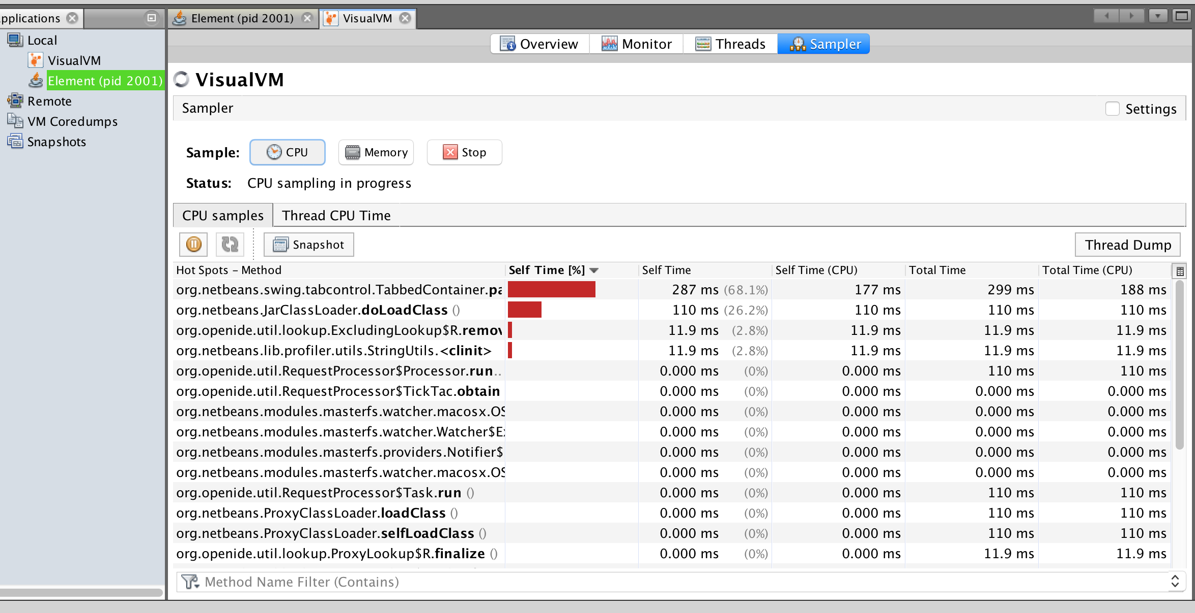

Mean Median Mode

Mean: 0m0.1328 s

Median: 0m0.1305 s

Mode: 0m0.129 s